Mini Project Report On
“Warehouse and Logistics Management System”

Submitted by:
Arush Yambarwar (RBT25CB041)
Ayush Shedame (RBT25CB040)

Under the guidance of
Prof. Rutuja S. Bachhav
Course: DBMS

Academic Year: 2026–27 (Semester III)

Table of Contents

1. Abstract 5
2. Introduction 6
3. Literature Survey / Existing System 7
4. Proposed System 8
5. Methodology / Implementation 10
6. Results and Discussion 14
7. Conclusion and Future Scope 15
8. References 16
9. Appendix (Optional) 17

- Course Outcomes:
CO1: Design a database schema and 2 –tier application for a given problem statement.
CO2: Design SQL DDL/DML quries to create, secure, populate, maintain, and query a database using integrity constraint, stored function/procedure, cursor, trigger using PL/SQL block.
CO2: Design NO SQL query using mongoDB platform.

- PO Mapped
PO1: Engineering Knowledge: Apply knowledge of mathematics, natural science, computing,
engineering fundamentals and an engineering specialization as specified in WK1 to WK4 respectively to develop to the solution of complex engineering problems
PO2: Problem Analysis: Identify, formulate, review research literature and analyze complex engineering problems reaching substantiated conclusions with consideration for sustainable development.
PO3: Design/Development of Solutions: Design creative solutions for complex engineering problems and design/develop systems/components/processes to meet identified needs with consideration for the public health and safety, whole-life cost, net zero carbon, culture, society and environment as required.
PO4: Conduct Investigations of Complex Problems: Conduct investigations of complex engineering problems using research-based knowledge including design of experiments, modeling, analysis & interpretation of data to provide valid conclusions.
PO5: Engineering Tool Usage: Create, select and apply appropriate techniques, resources and modern engineering &amp; IT tools, including prediction and modeling recognizing their limitations to solve complex engineering problems.
PO8: Individual and Collaborative Team work: Function effectively as an individual, and as a member or leader in diverse/multi-disciplinary teams.
PO9: Communication: Communicate effectively and inclusively within the engineering community and society at large, such as being able to comprehend and write effective reports and design documentation, make effective presentations considering cultural, language, and learning differences
PO10: Project Management and Finance: Apply knowledge and understanding of engineering management principles and economic decision-making and apply these to one’s own work, as a member and leader in a team, and to manage projects and in multidisciplinary environments.
PO11: Life-Long Learning: Recognize the need for, and have the preparation and ability for i) independent and life-long learning ii) adaptability to new and emerging technologies and iii) critical thinking in the broadest context of technological change.

- PSO Mapped
PSO 1: Integrated Technical Proficiency: Ability to analyze, designs, and implement comprehensive software and business systems using modern tools and techniques, ensuring intelligent, efficient, and sustainable solutions.
PSO 2: Data-Driven Decision Making: Ability to apply mathematical and data analytics methods including algorithms, statisticalmodels, and data structures to solve complex computational and business problems and support innovation.
PSO 3: Interdisciplinary Collaboration &amp; Professionalism: Ability to effectively collaborate in multidisciplinary teams, integrating technical and business perspectives, and to communicate and manage projects with professional ethics and societal responsibility.
- SDG Goals Mapped
SDG 4: Quality Education: Develops students’ practical skills in database design, SQL, PL/SQL, NoSQL, and modern database technologies.
SDG 8: Decent Work and Economic Growth: Enhances students’ technical and problem-solving skills required for employment and professional development in the IT industry.
SDG 9: Industry, Innovation and Infrastructure: Promotes the development of technology-based database solutions using SQL, PL/SQL, and MongoDB.
SDG 12: Responsible Consumption and Production: Encourages efficient data management, storage, and utilization of computing resources.

- Abstract
Warehouse operations need an accurate record of the products stored at each location and a reliable way to account for stock when goods are dispatched or a shipment is cancelled. This mini project describes a Warehouse and Logistics Management System with a MySQL relational database, an Express API, and a React interface. The data model separates warehouses, products, inventory, carriers, carrier contacts, shipments, and shipment items into seven tables. Primary and foreign keys connect these records, while uniqueness and quantity constraints protect basic data quality.
A database trigger is designed to reject shipment items when stock is insufficient and to deduct available stock when items are added. A second trigger restores stock when a shipment changes to Cancelled. A stored procedure handles restocking, and views support utilization, low stock, carrier performance, popular products, and late shipments. The design demonstrates how relational modeling and database logic can keep operational rules close to the data.
The accompanying guide describes demo scenarios, but executable SQL files and a running instance were not included with the supplied materials; numerical outcomes in this report are illustrative rather than independently measured.

- Introduction
2.1 Background / Motivation
A regional logistics operation may store the same product in multiple warehouses and dispatch it through different carriers. A product catalog alone cannot answer how many units remain in a given location, whether a shipment has enough stock, or which dispatches are overdue. These questions require linked records and consistent updates.
2.2 Problem Definition
Manual spreadsheets and disconnected records can duplicate product information, lose the relationship between a shipment and its line items, and leave inventory counts incorrect after a dispatch or cancellation. The project addresses these issues through a normalized relational schema and database rules for stock movement.
2.3 Objectives
- Record warehouses, products, carriers, contacts, inventory, shipments, and shipment items with clear keys and relationships.
- Check stock availability during dispatch and prevent the available quantity from becoming negative.
- Restore stock once when an active shipment is cancelled.
- Support restocking and expose useful reports through database views.
- Provide a browser interface through an Express API connected to MySQL.

- Literature Survey / Existing System
3.1 Existing Approach and Gap
A basic spreadsheet or isolated stock register can record quantities, but updates depend on every operator applying the same rules. Separately maintained dispatch logs make it difficult to reconcile inventory with shipment items. In the proposed database, foreign keys preserve links and stock logic executes within MySQL, including when a client bypasses the web interface.
3.2 Feasibility
The feasibility of the project was assessed from three aspects, summarized in Table 1.
Table 1: Feasibility assessment
Aspect | Assessment
Technical | MySQL 8, Node.js, Express, React, and Vite form a conventional local development stack. InnoDB supports transactions and foreign keys.
Operational | Warehouse users can enter stock and shipments, review low stock, and inspect dispatch status through separate screens.
Cost | The described stack can be developed with commonly available local tools. Hosting, staffing, and production operations are outside this project scope.

Conclusion of the survey: manual and disconnected records cannot guarantee consistent stock, whereas a keyed relational schema with database-level rules can. This is the gap our project addresses.

- Proposed System
4.1 System Overview
The user works in a React browser application. It sends requests to an Express REST API. The backend uses a mysql2 promise connection pool to query the MySQL database. Tables hold operational data; triggers, a procedure, and views implement stock rules and reports.
4.2 Features / Scope
The system is divided into the functional modules listed in Table 2.
Table 2: Functional modules
Module | Main function
Warehouse and product | Maintain locations, storage capacities, catalog details, and unique SKUs.
Inventory | Track a product in each warehouse with available quantity, threshold, and restock date.
Carrier | Record transport type and separate contact entries.
Shipment | Record source warehouse, carrier, destination, expected delivery, status, and line items.
Analytics | Read utilization, low stock, carrier performance, top products, and late shipments from views.

4.3 System Architecture Diagram
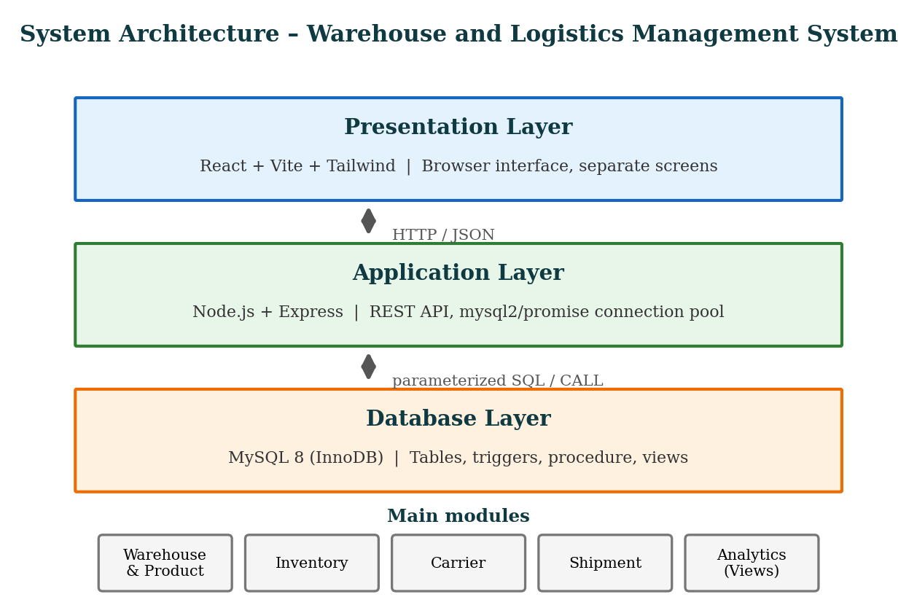
Figure 1: Three-layer architecture of the Warehouse and Logistics Management System
Flow: Browser interface → Express API → MySQL 8 database. The user works in the browser, the API sends the queries through the connection pool, and the triggers, procedure and views inside MySQL apply the stock rules, so the rules hold even when a client bypasses the web interface.

- Methodology / Implementation
5.1 Tools and Technologies Used
The guide specifies MySQL 8 with InnoDB; an Express backend using mysql2/promise; and a React frontend built with Vite and Tailwind. MySQL Workbench is used to run schema and seed scripts and to reverse engineer the relational diagram.
Table 3: Tools and technologies used
Component | Technology | Purpose
Front end | React, Vite, Tailwind | Browser interface with separate screens
Back end | Node.js + Express | REST API
DB driver | mysql2/promise | Connection pool between Express and MySQL
Database | MySQL 8 (InnoDB) | Tables, triggers, procedure, views, transactions and foreign keys
Design tool | MySQL Workbench | Runs schema and seed scripts; reverse engineers the relational diagram

5.2 Database Design and ER Diagram
The database has seven tables. Primary and foreign keys connect them, and uniqueness and quantity constraints protect basic data quality. The core entities and keys are listed in Table 4 and the ER diagram is shown in Figure 2.
Table 4: Core entities and keys
Table | Primary key | Important relationship or rule
warehouse | warehouse_id | state, city, locality; storage_capacity > 0
product | product_id | sku is unique; price ≥ 0
inventory_stock | stock_id | FKs to warehouse and product; unique warehouse/product pair; quantity ≥ 0
carrier | carrier_id | transport_type is Road, Rail, Air, or Sea
carrier_contact | carrier_id, contact | carrier_id references carrier; one row per contact
shipment | shipment_id | FKs to carrier and source warehouse; tracking_no unique
shipment_item | shipment_id, item_no | FKs to shipment and product; quantity > 0; shipment deletion cascades

A warehouse has many inventory rows and shipments. A product appears in many inventory rows and shipment items. A carrier has many contacts and transports many shipments. A shipment contains many shipment items. Inventory resolves the many to many relationship between warehouses and products; each shipment item depends on its parent shipment.
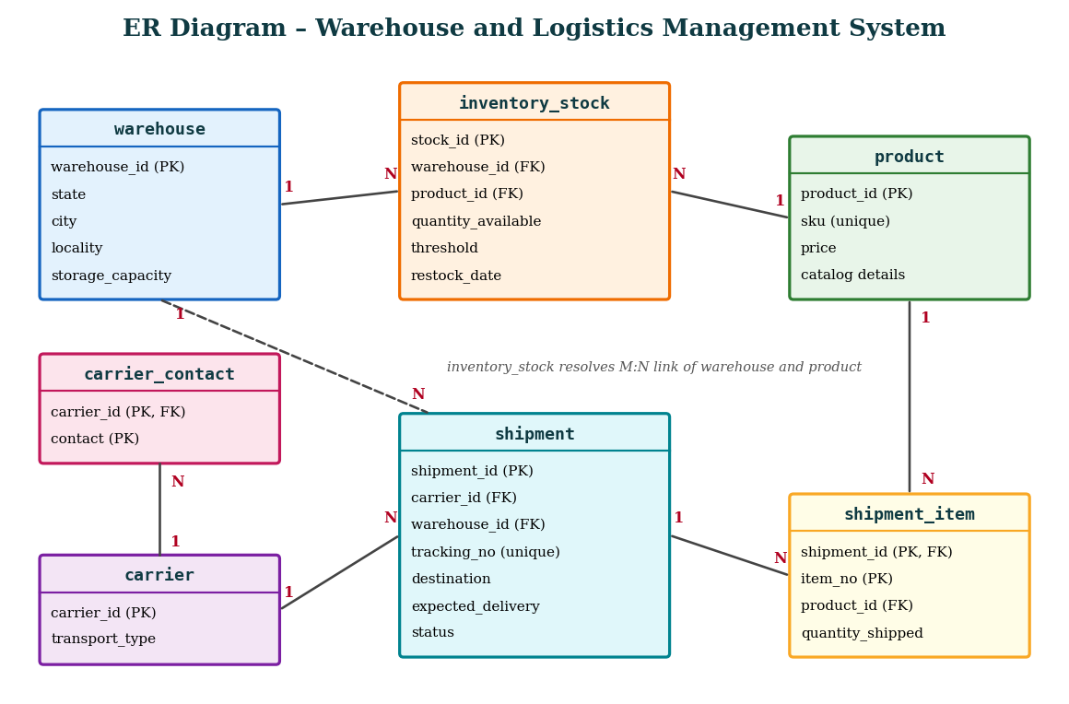
Figure 2: ER diagram of the Warehouse and Logistics Management System
Table 5: Entity relationships
Entity (One side) | Entity (Many side) | Cardinality
Warehouse | Inventory (inventory_stock) | 1 : N
Product | Inventory (inventory_stock) | 1 : N
Warehouse | Shipment (source warehouse) | 1 : N
Carrier | Shipment | 1 : N
Carrier | Carrier contact | 1 : N
Shipment | Shipment item | 1 : N
Product | Shipment item | 1 : N

5.3 Mapping and Normalization
The composite warehouse location is flattened into state, city, and locality. Carrier contacts become separate rows instead of comma-separated values. The shipment item is identified by (shipment_id, item_no), and its foreign key to shipment uses ON DELETE CASCADE. These mappings keep attributes atomic for 1NF. Non-key values in tables with composite keys depend on the full key for 2NF. Product and warehouse descriptions stay in their own tables rather than being copied into inventory or shipment rows, avoiding the transitive dependencies targeted by 3NF.
This is a structural assessment from the guide; complete DDL would be needed to verify every functional dependency.
5.4 Dispatch and Cancellation Logic
When a shipment item is inserted, trg_deduct_stock finds the parent shipment’s source warehouse and checks the matching inventory row. If the requested quantity exceeds stock, the trigger raises SQLSTATE 45000. Otherwise it reduces quantity_available. On a status transition into Cancelled, trg_restore_stock_on_cancel adds the shipment item quantities back to that warehouse. The transition condition prevents a repeated Cancelled update from restoring stock twice.
5.5 Procedure and Views
The stored procedure and the views are summarized in Table 6.
Table 6: SQL constructs implemented
Construct | Name | Purpose
Trigger | trg_deduct_stock | On shipment item insert: checks the source warehouse stock, raises SQLSTATE 45000 if insufficient, otherwise deducts quantity_available
Trigger | trg_restore_stock_on_cancel | On status change into Cancelled: adds the shipment item quantities back to the source warehouse, only once
Stored procedure | sp_restock_product | Increases an existing inventory row or creates a new row, then records the restock date
View | v_warehouse_utilization | Compares summed available units with warehouse capacity
View | v_low_stock | Selects items at or below their thresholds
Views | v_carrier_performance, v_top_products, v_late_shipments | Summarize delivery, product, and delay information

5.6 Representative SQL Behavior
The two statements below are excerpts documented in STUDENT_GUIDE.md. Complete trigger definitions were not supplied.
Insufficient stock: SIGNAL SQLSTATE '45000' SET MESSAGE_TEXT = 'Insufficient stock for product in source warehouse.'
Stock deduction: UPDATE inventory_stock SET quantity_available = quantity_available - NEW.quantity_shipped WHERE warehouse_id = v_warehouse_id AND product_id = NEW.product_id;
5.7 Screenshots or Outputs
No screenshots were included among the supplied materials. Replace each placeholder below with a screenshot of the running application.
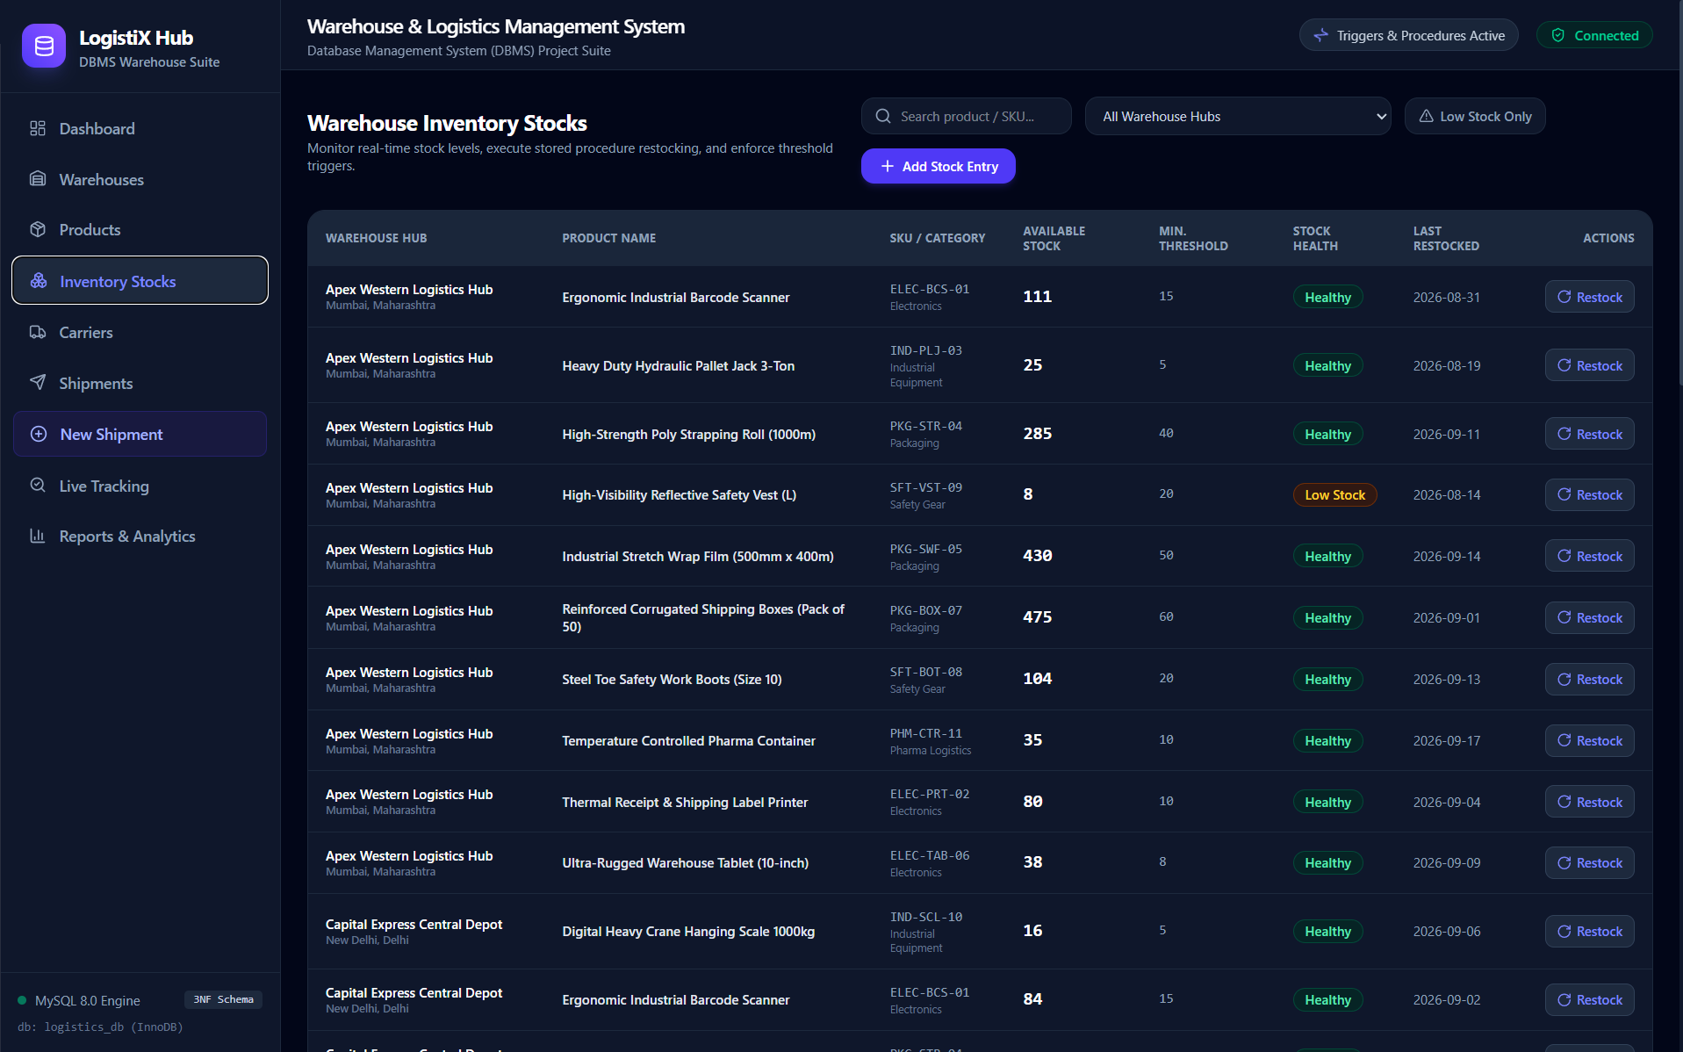
Figure 3: Inventory screen
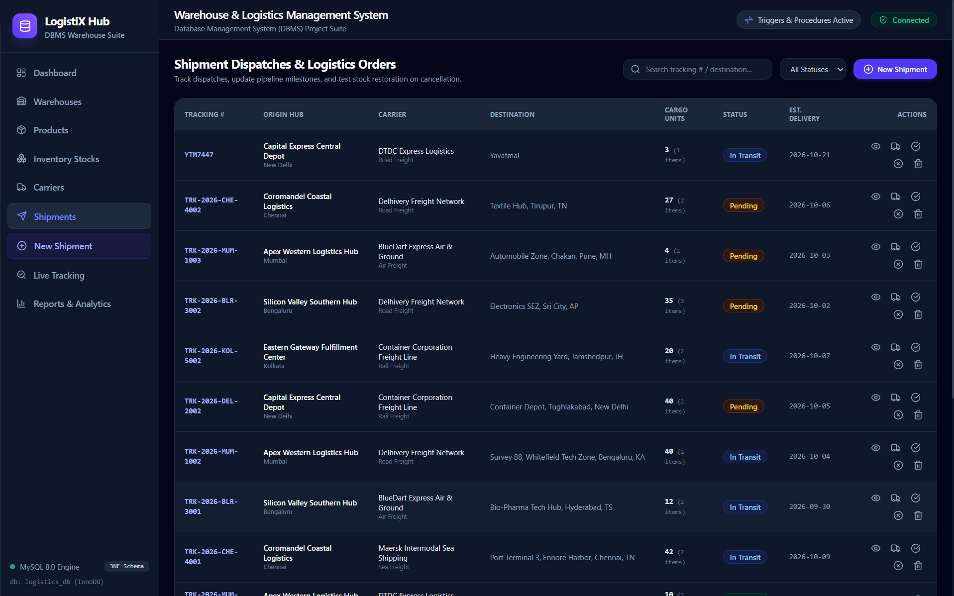
Figure 4: Shipment dispatch
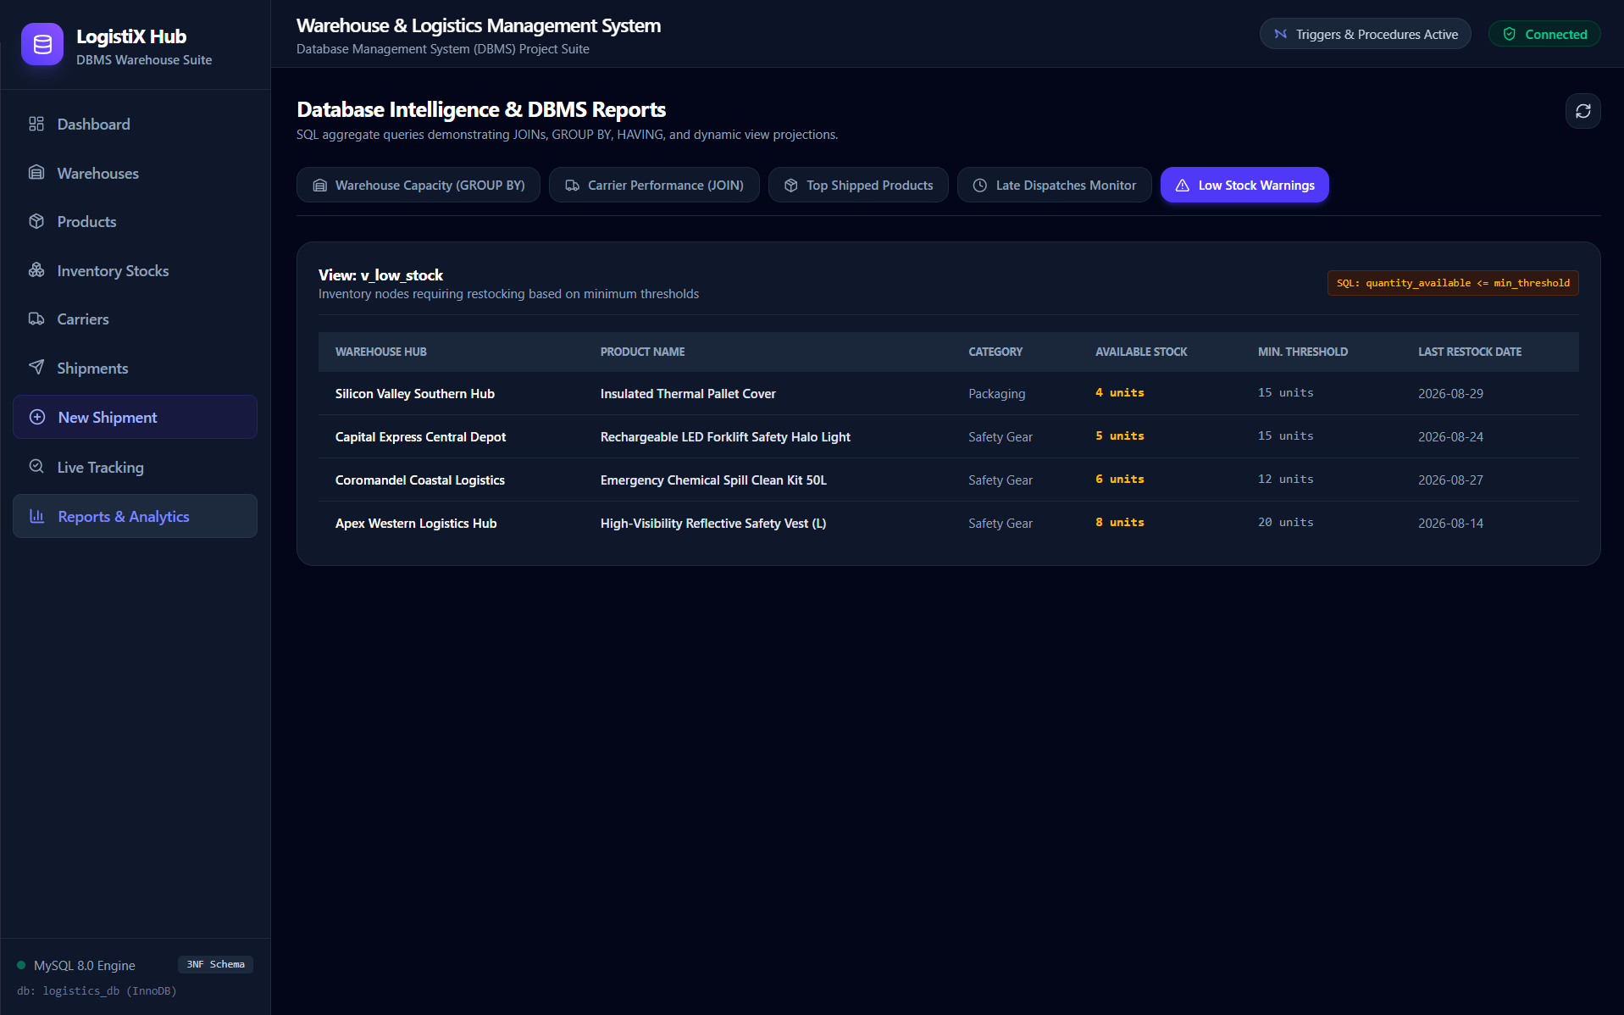
Figure 5: Low stock and utilization views
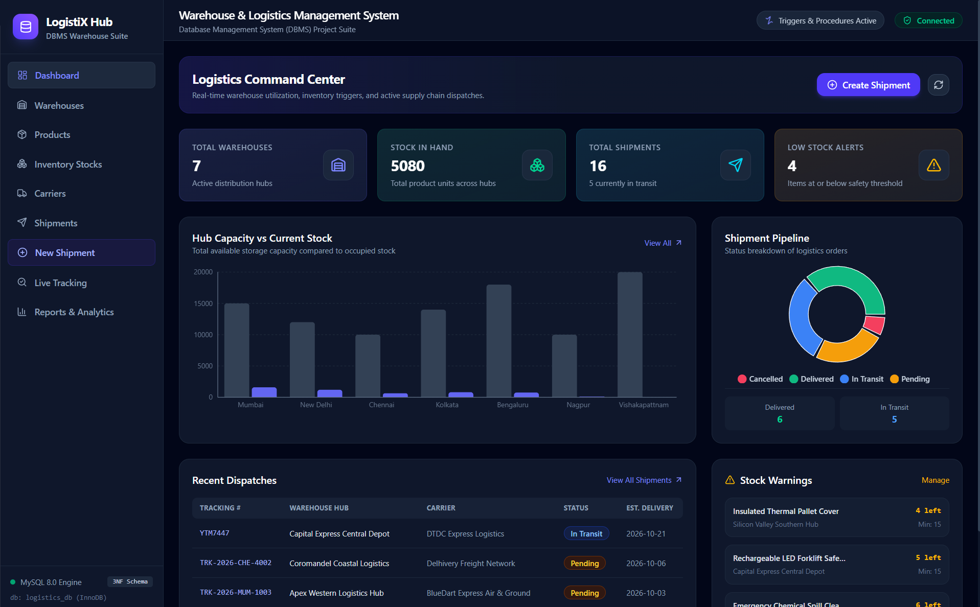
Figure 6: Insufficient stock error

- Results and Discussion
6.1 Demonstration Scenarios Described in the Guide
Table 7: Demonstration scenarios and expected results
Scenario | Expected result
Dispatch 10 units from 120 | Quantity becomes 110 after a valid shipment item is inserted.
Request 999 units when 10 remain | The trigger rejects the item with an insufficient stock error.
Cancel an active shipment | The cancellation trigger returns its item quantities to the source warehouse.
Restock 50 units | The procedure increases or creates the inventory row and updates the restock date.

These are expected outcomes from the submitted guide, not measured test results. No screenshots, database files, or executable backend were included among the supplied attachments, so the report does not claim that these scenarios were run during preparation.
6.2 Discussion
Foreign keys protect references between modules, uniqueness rules prevent duplicate SKUs and warehouse/product pairs, and the stock triggers centralize the inventory rules. The views make repeated reporting queries easier to consume. Before production use, the dispatch transaction, concurrent stock updates, cancellation edge cases, capacity enforcement, user access, and error handling would need direct tests against the actual implementation.

- Conclusion and Future Scope
7.1 Summary of Achievements
The proposed system organizes seven related tables around inventory and shipment processing. It uses keys, normalization, triggers, a restocking procedure, and reporting views to support consistent warehouse records. The guide supplies a clear demonstration plan.
- Seven related tables for warehouses, products, inventory, carriers, contacts, shipments and shipment items.
- Stock deducted on dispatch, with insufficient stock rejected by a trigger.
- Stock restored once when an active shipment is cancelled.
- A restocking procedure and five reporting views.
7.2 Limitations and Future Scope
Limitations. Executable SQL files, a running instance and screenshots were not supplied, so the outcomes in this report are expected results from the guide rather than measured results.
Future scope. The next step is to run the demonstration plan on the actual SQL scripts and application, capture output screenshots, and document observed results. Further improvements could include:
- User roles for warehouse staff and administrators.
- Audit logs for stock movement.
- Stronger validation of capacity limits.
- Automated tests for concurrent dispatches.

- References
[1] STUDENT_GUIDE.md, Warehouse and Logistics Management System, supplied project guide.
[2] Mini Project Report_DBMS.docx, supplied college report format.
[3] DBMS_Mini Project PPT.pptx, supplied college presentation format.

- Appendix (Optional)
A. Demonstration checklist
- Create a shipment item with sufficient stock and compare inventory before and after.
- Attempt a shipment item exceeding available stock and capture the database error.
- Cancel an active shipment and verify stock is restored once.
- Call the restocking procedure and query the low stock and utilization views.
B. SQL excerpts from the guide
SIGNAL SQLSTATE '45000'
SET MESSAGE_TEXT = 'Insufficient stock for product in source warehouse.';

UPDATE inventory_stock
SET quantity_available = quantity_available - NEW.quantity_shipped
WHERE warehouse_id = v_warehouse_id
AND product_id = NEW.product_id;
C. Other SQL features described
- Trigger trg_deduct_stock and trigger trg_restore_stock_on_cancel
- Stored procedure sp_restock_product
- Views v_warehouse_utilization, v_low_stock, v_carrier_performance, v_top_products, v_late_shipments
D. Additional screenshots
